1. Test Suit runned when the APIs where not created .

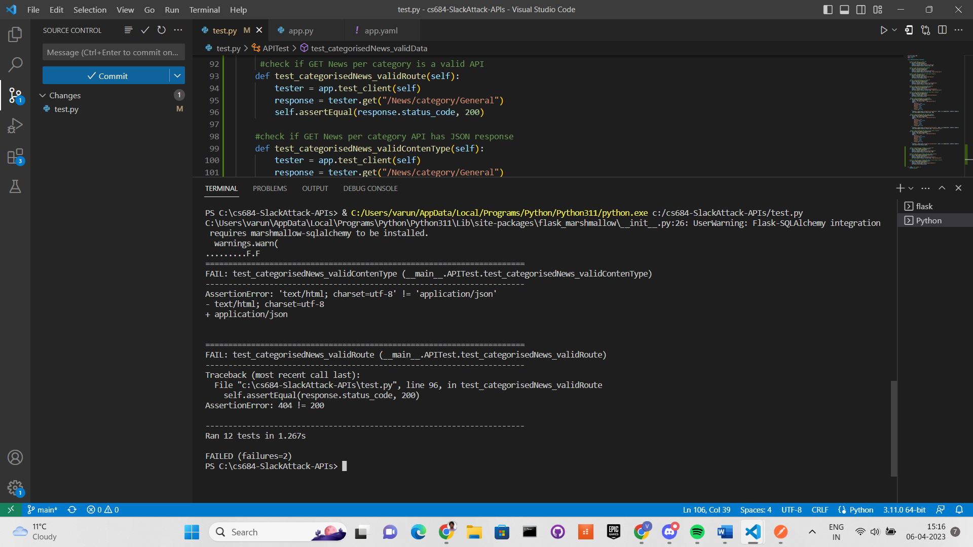

1. Test Suit ran during the API development.

1. Test Suit when the API development was finished.

